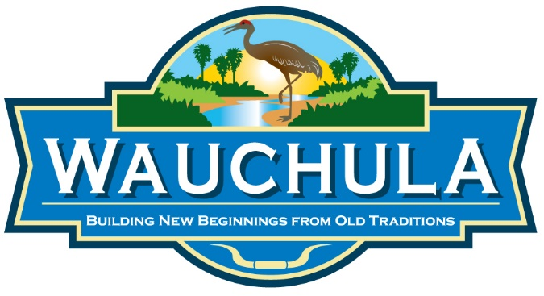

Peace River Park
1322 East Main Street
Wauchula, FL 33873

Peace River Park is owned and maintained by the City of Wauchula. The amenities include fishing, hiking, exercise trails and primitive tent camping at no charge to the park patrons. The park hours are from 7 am until dusk. The following rules and regulations must be adhered to; any violations may result in being trespassed from the park.

- Alcoholic beverages, profanity and obscenity WILL NOT be permitted.
- Hunting in the park is not permitted.
- The use of motorized vehicles, including all-terrain vehicles, is not permitted.
- Camp in designated sites only.
- No ropes or wires shall be attached to trees or buildings.
- Camp fires are allowed within provided fire rings. Searching for fire wood that has fallen is acceptable. However, cutting wood is NOT ALLOWED.
- All camp sites must be kept in a neat and orderly fashion.
- All trash must be placed in garbage cans or dumpsters provided.
- All camp sites must be left clean upon departure.
- All camping is limited to 14 days. Extended reservations may be granted on a case-by-case basis. This will not be grounds for an adverse possession claim. You must leave the park for at least fourteen days before returning.
- Children are the responsibility of the parent/guardian at all times.
- Pets are welcome, but must be on a leash at all times. ALL PET WASTE MUST BE CLEANED UP BY THE PET OWNER.
- No feeding of wildlife at any time.

*******RULES ARE SUBJECT TO CHANGE WITHOUT NOTICE*******

